10 November 2022

**Bullying Prevention Week 14th – 18th November 2022**

Dear Parents

On Monday of **Anti-Bullying Week,** we will hold **Odd Socks Day** where we ask everyone in school to wear odd socks to school to celebrate what makes us all unique. This will be on **Monday 14th November.**

The theme for this year’s anti bullying campaign is **Reach Out**. There are lots of different reasons someone might need to reach out. It might be that they are being bullied, they could be involved in bullying others and want to stop, or perhaps they have seen bullying happening and want to help.

We will work with the children using the definition of bullying as:

**Bullying is the repetitive, intentional hurting of one person or group by another person or group, where the relationship involves an imbalance of power. It can happen face to face or online.**

We will learn specifically about caring friendships, respectful relationships and online safety and how to develop healthy and positive relationships with others.

The Anti-Bullying Alliance have resources to support children at home - [Parents and Carers (anti-bullyingalliance.org.uk)](https://anti-bullyingalliance.org.uk/anti-bullying-week/parents-and-carers)

For further information on how we support children in school who may be victims of bullying, please see our Bullying Prevention Policy - <https://www.aecps.org/page/behaviour-management/113816>

If you feel that your child is a victim of bullying please let us know immediately so we can support.

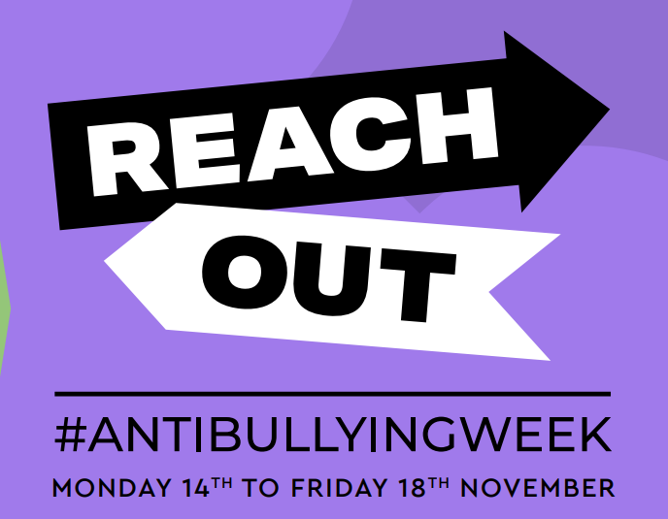

Kind regards



Lindsey Walsh

Head Teacher