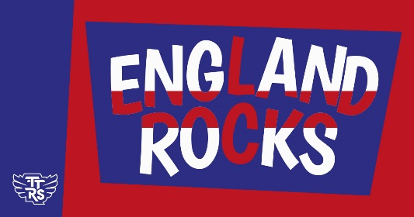

Wednesday 9th November 2022

Dear Parents

**Join the competition and improve your child’s times tables!**

AECPS are celebrating Maths Week England by taking part in a friendly times tables (and division) competition. The competition runs from 07:30 GMT Monday 14th November to 19:30 GMT Wednesday 16th November. It's all done online via play.ttrockstars.com.

Children can play in any game mode with every correct answer to a multiplication or division question, earning themselves, their class and the school a point. The Times Tables Rock Stars platform will calculate the class average (the number of correct answers per pupil in the class who play during the competition hours, subject to a daily 60-minute limit (see below). The winning class in the school will be the one with the highest average. There will also be individual class winners for the pupils who contribute the most points to their class’ total.

To support player wellbeing, there is a daily time limit of 60-minutes per player. In other words, each player can earn competition points for up to 60-minutes between 07:30 GMT and 19:30 GMT on 07:30 GMT Monday 14th November to 19:30 GMT Wednesday 16th November. Once the player goes beyond 60-minutes of play on that day, they will still earn coins but will no longer earn points towards the competition.

In the spirit of the competition, please don't play on their behalf but by all means encourage and support them to the extent that it doesn't cause high stress levels or impact on family plans.

Yours Sincerely

Miss Burnett

Year 4 Teacher and TT Rockstars Lead