Alderley Edge Community Primary School Exclusions Policy

|  |  |
| --- | --- |
| **Date of adoption by Governing Board** | 28/11/24 |
| **Review cycle** | Annual |
| **Date of next review** | 28/11/25 |

|  |  |
| --- | --- |
| Contents | |
| 1. | Aims |
| 2. | Rationale for Exclusions |
| 3. | Types of Exclusion |
| 4. | Roles and responsibilities |
| 5. | Monitoring and Evaluation |
| 6. | Related policies |
| 7. | Appendix 1: AECPS Exclusion Protocol |
| 8. | Appendix 2: Exclusion process flow once a decision to exclude has been made |
| 9. | Appendix 3: Sample letters |
| 10. | Appendix 4: Useful links |

**Alderley Edge Community Primary School Exclusion of Pupils Policy**

1. **Aims**

The Governors of Alderley Edge Community Primary School are committed to ensuring the safety and well-being of all members of its school community and maintaining an educational environment in which all can succeed. Exclusion is viewed as a very extreme sanction to be used when all other available strategies have been exhausted or where there are exceptional circumstances and it is not appropriate to implement other strategies. Our school’s Positive Behaviour Management policy details our expectations of pupil behaviour and our whole school approach to behaviour management.

Our objectives for this exclusions policy are as follows:

* To be well publicised (via the website) and easily accessible
* To be fair and balanced
* To be used when all other avenues have been explored
* To ensure a fair investigation
* To allow for an appeal where appropriate/required

1. **Rationale for exclusion**

Exclusion is an extreme sanction that is only administered by the Head Teacher. Exclusion, whether fixed term or permanent may be used for serious or persistent breaches of the school’s rules. Examples of breaches include, but are not limited, to the following:

* Bullying including cyber bullying / improper use of social media
* Actions which put the child or others in danger
* Verbal abuse of staff or child
* Physical abuse of staff or child
* Inappropriate sexual behaviour
* Damage to property
* Theft
* Carrying an offensive weapon
* Arson
* Disruptive or defiant behaviour
* Unacceptable behaviour which has previously been reported for which interventions have been unsuccessful
* Assault
* Possession of or under the influence of illegal substances
* Other situations where the Headteacher makes the judgement that exclusion is an appropriate sanction

The school may apply a sanction (including fixed period or permanent exclusion) for poor behaviour away from the school premises which is either witnessed by a member of staff (for example on a school related activity) or reported to the school and is proven to be accurate.

‘Informal’ or ‘unofficial’ exclusions, such as sending a pupil home ‘to cool off’, are unlawful, regardless of whether they occur with the agreement of parents or carers. Any exclusion of a pupil, even for short periods of time, must be formally recorded.

**Children with Special Educational Needs**

Alderley Edge Community Primary School will take account of any special educational needs when considering whether or not to exclude a pupil and will take reasonable steps to ensure that a pupil is not treated less favourably for reasons related to their disability. Reasonable steps include:

* Adaption in the school’s behaviour policy
* Developing strategies to prevent the pupil’s behaviour
* Requesting external help with the pupil
* Staff training

1. **Types of Exclusion**

There are two types of exclusion:

**A. Fixed Period Exclusion**

Fixed Period Exclusions are limited to a maximum of 45 school days in any one year. The length of the exclusion will be determined by the headteacher depending upon the severity of the offence. The first exclusion will usually last between half of one day up to 5 days. In exceptional cases, usually where further evidence has come to light, a further fixed-period exclusion may be issued to begin immediately after the first period ends; or a permanent exclusion may be issued to begin immediately after the end of the fixed period.

* **Procedure for Fixed Period Exclusion\***

1. On the day of the offence, the child’s parents/carers will be informed of the exclusion, its length and the specific reason for it. This will be communicated by letter and, if possible, by talking to the parents/carers. Parents/carers will also be informed in writing that they have rights to make representations to the governing body and Cheshire East Council Local Authority (CEC)
2. The head teacher will inform the school’s governing body and CEC immediately where the total exclusions in the current term for that pupil will exceed 5 days, or where a public examination or national curriculum test will be missed.

All shorter exclusions will be reported to the school governing body and CEC once per term. If the total exclusions in the current term for that pupil exceed 15 days, the school’s governing body will convene an exclusions committee to consider the reinstatement of the excluded pupil within 15 days of receiving the notification. Parents/Carers, and a local authority representative will be invited to make representations at the meeting.

1. The head teacher will make arrangements for the excluded child to receive schoolwork to do at home until he/she returns to school up to the fifth day. If the exclusion is for more than 5 days, the school must make arrangements for full-time education somewhere else from the sixth day.

**B. Permanent Exclusion**

The decision to exclude a child permanently is taken very seriously. There are two main types of situation in which permanent exclusion may be considered;

1. As a final formal step following the use of a wide range of other strategies that have been unsuccessful in dealing with disciplinary offences.
2. Where there are exceptional circumstances and it is not appropriate to implement other strategies and where it would be appropriate to permanently exclude a child for a first “one-off” offence.

In all cases a decision taken to permanently exclude must meet the following DfE criteria;

In response to a serious breach, or persistent breaches of the School Behaviour Policy; **and**

where allowing the child to remain in school would seriously harm the education or welfare of the pupil or other members of the school.

* **Procedure for Permanent Exclusion\***

1. On the day of the exclusion, the child’s parents/carers will be informed of the exclusion, the fact that it is permanent and the specific reason for it. This will be communicated by letter and, if possible, by talking to the parents/carers. Parents/carers will be informed in writing that they have rights to make representations to the governing body and Cheshire East Local Authority.
2. The head teacher will notify, in writing, the L.A. and the school’s Governing Body immediately.
3. The school’s governing body will convene an exclusions committee to consider the reinstatement of the excluded pupil within 15 days of receiving the notification. Parents/Carers, and an L.A representative will be invited to make representations at the meeting.
4. The child remains on the school’s register until the appeals procedure is completed, or until the parents/carers confirm that they accept the exclusion and intend to make other arrangements.
5. The head teacher will arrange for work to be set and monitored during the period of appeal.

* These procedures are a simplified summary of the procedures outlined in the DfE exclusion guidance document that can be found using this link: <https://www.gov.uk/government/publications/school-exclusion>

Appendix 2 contains an ‘Exclusions process flow chart once a decision to exclude has been made’.

1. **Roles and Responsibilities**

**Head Teacher**

The DfE statutory guidance states that only the head teacher of a school can exclude a pupil. Exclusion is an extreme sanction that is only administered by the Head Teacher (as defined above). In reaching a decision on exclusion, the Head Teacher will always look at each case on its own merits.

The Head Teacher may contact the Cheshire East School Exclusion team for guidance and will have regard to the Department for Education statutory guidance; “Exclusion from maintained school, academies and pupil referral units in England”

The exclusion protocol for Alderley Edge Community Primary School should be followed for all exclusions and can be found in Appendix 1.

**The Governing Board**

The Governing Board will monitor the implementation of this policy and will keep under regular review the number of exclusions being made including a comparison with national data. The Governing Body has a duty to review the decision to exclude in the following circumstances;

1. If the exclusion is permanent
2. If the exclusion is fixed term and would bring the pupil’s total number of school days of exclusion to more than 15 in a term
3. If the exclusion would result in a pupil missing a public examination or national curriculum test
4. Representations are made by or on behalf of parents of an excluded child

In circumstance a-c above the Governing Board will convene a Governors Exclusion Committee (GDC) meeting within 15 school days of receiving notice of the exclusion, to consider reinstating the excluded pupil. In light of its consideration the GDC can either;

* Decline to reinstate the pupil or
* Direct reinstatement of the pupil immediately or on a particular date

In any Governors Exclusion Committee meeting to consider an exclusion, the Head Teacher who has made the legal decision to exclude will submit a report to the committee which they will present in the meeting.

In the circumstances of d) above, where representation is being made by, or on behalf of, a parent of an excluded child, the Governing Board must consider those representations but it cannot direct reinstatement if the fixed term exclusion does not bring the total number of days of exclusion to more than 5 in a term.

Where the Governing Board is unable to form an independent panel without any prior knowledge of the pupil or the background to the exclusion, the Governors may invite Governors from another school to form an independent panel.

The Governors Exclusion Committee will have regard to the DfE statutory guidance “Exclusion from maintained schools, academies and pupil referral units in England” in reviewing any decisions to exclude.

1. **Monitoring and Evaluation**

The effectiveness of this policy will be monitored against the following criteria:

* Compliance with statutory requirements
* Number of and reasons for exclusions
* Outcome of reviews and appeals

1. **Related Policies**

* 21. Positive Behaviour Management
* 27. Equal Opportunities
* 68. Prevention and Managing of Bullying
* 74. Racial Equality
* 70. Reasonable Use of Force
* 36. Child Protection and Safeguarding
* 107. Peer on Peer Abuse
* 13. Additional Needs
* 16. Attendance
* 114. Substance Misuse Policy
* 60. Complaints Policy

1. **Appendix 1 – Alderley Edge Community Primary School Exclusion Protocol**

The following protocol must be completed for all External Exclusions:

|  |  |  |
| --- | --- | --- |
| **!** | Only the Headteacher can make the decision to exclude. In the event that the Headteacher is not on the school site, every attempt must be made to contact them prior to excluding. If the Headteacher cannot be contacted, the Acting Headteacher (as specified in the scheme of delegation) may proceed. | |
|  | **Protocol** | **Complete** |
| 1 | The child must have the opportunity to put their case with a signed written statement being obtained if at all possible. For younger children where this is not possible all effort must be made to hear the child’s voice, for example through a verbal statement taken by a trusted adult. |  |
| 2 | Witness statements must be obtained whenever possible. |  |
| 3 | The Class Teacher, Head Teacher (and SENCO where appropriate) must consult on the facts. |  |
| 4 | The child’s attendance and behaviour records must be considered. Alternative sanctions may be considered. |  |
| 5 | Head Teacher to inform the Chair of Governors of any full time exclusion. This can be after the event to take into account the need for swift action in some circumstances. |  |
| 6 | Head Teacher to consult with the Chair of Governors prior to making the decision to permanently exclude. |  |
| 7 | The Head Teacher must satisfy themselves that this protocol has been followed before making the final decision. |  |
| 8 | If an external exclusion is decided upon, parents, carers or guardians must be contacted immediately by phone. A letter is sent by post and a re-admission meeting booked with the parents, child, and the Head Teacher. |  |
| 9 | Where applicable, the victim’s parents, carers or guardians should be informed |  |
| 10 | Exclusion letter to be sent by first class post and emailed to parents |  |
| 11 | Advise the Cheshire school exclusions team  * email:  [ExclusionCE@cheshireeast.gov.uk](mailto:ExclusionCE@cheshireeast.gov.uk) * telephone: 01270 375255 |  |
| 12 | All considerations, decisions and actions must be documented in writing |  |

Child’s Name: Year Group: Date:

Signed……………………………………………………………………Head Teacher

Date………………………………….

1. **Appendix 2 – Exclusions Process Flow Chart once a decision to exclude has been made**

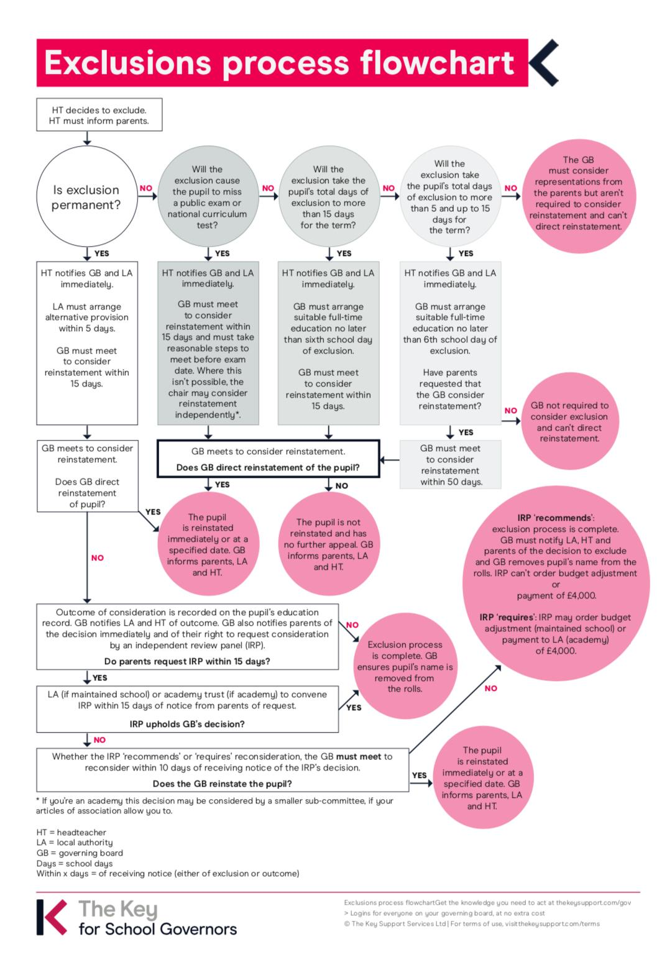

1. **Appendix 3 – Sample letters**

Please note that all these appendices are copies taken from the CE Intranet and at the time they were included in this policy were current. Users of this policy ***MUST*** check to make sure the advice has not changed:

* Sample letters for schools following an exclusion available from Cheshire East via CHESS HUB - <https://www.chesshub.co.uk/>

1. **Appendix 4 – Useful Links**

* Sample letters for schools following an exclusion available from Cheshire East via CHESS HUB - <https://www.chesshub.co.uk/>
* Cheshire East Council exclusions information for Parents:

<https://www.cheshireeast.gov.uk/schools/school-attendance/school-exclusions.aspx>

* Changes to the School Exclusion process during the coronavirus outbreak:

<https://www.gov.uk/government/publications/school-exclusion/changes-to-the-school-exclusion-process-during-the-coronavirus-outbreak>

* Government’s Statutory guidance on School suspensions and permanent exclusions: <https://www.gov.uk/government/publications/school-exclusion>