
Alderley Edge Community Primary School Staff
September 2024


Mrs Lindsey Walsh Miss Lyndsey Platt Miss Melanie Rose Mrs Lesley Sym
(Headteacher) (Deputy Headteacher) (Teacher / SENDCO) (Teacher)

Mrs Emma Gallimore Mrs Rowley Louise Mrs Nikita Salt Miss Elsha Rushe (Teacher) (Teacher) (Teacher) (Teacher)

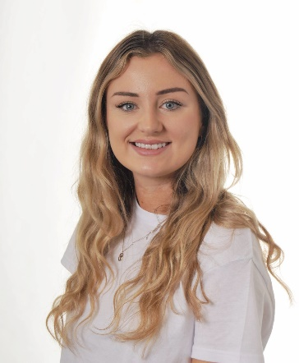
Miss Laura Hibbert Miss Julia Burnett Mrs Ruth Lewis Miss Suzie Wallace
(Teacher) (Teacher) (PE Teacher) (Learning Support Assistant/
MFL Teacher)
    Mrs Suzy Broadrick Mrs Ania Shotton Mrs Angela Aiken Mrs Rachel French
(Bursar) (Clerical Assistant) (Music Teacher) (Learning Support Assistant)

Miss Sarah Trust Miss Hannah Rowson Mrs Karen Stanbury Mrs Vanessa Lamb
(Learning Support Assistant) (Learning Support Assistant) (Learning Support Assistant) (Learning Support Assistant) 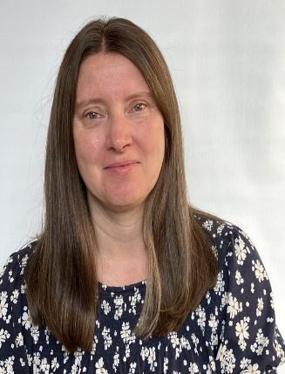  
Mrs Siu Lau Mrs Julie Jackson Mrs Kathryn Reynolds Miss Leona Heeney
(Learning Support Assistant) (Learning Support Assistant) (Learning Support Assistant) (Learning Support Assistant)


Mr Tony Guest Mrs Julia Guest Miss Helen Fitchett Mrs Anne Fearn
(Midday Assistant) (Midday Assistant) (Midday Assistant) (Midday Assistant

Mrs Ruth Share Mrs Jackie Burt Mrs Joanne Vanden
(Squirrel Club Deputy Manager) ( Site Manager) (Learning Support Assistant)

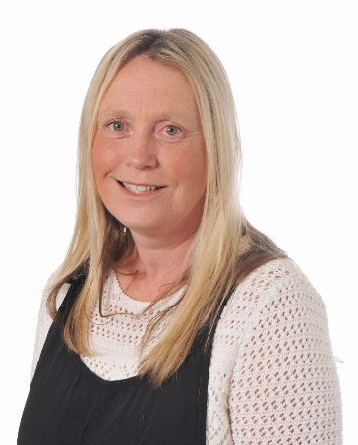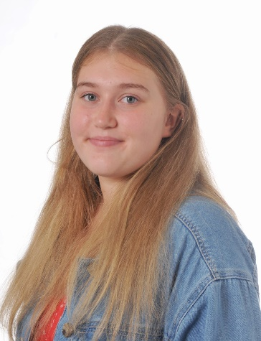
Mrs Ann Singh Mrs Joanne Aymes Miss Mia Share
(Playworker) ( Midday Assistant/Playworker) ( Playworker)

