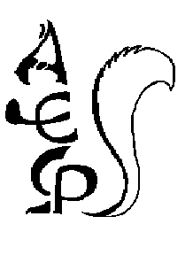
MINUTES OF AN EXTRAORDINARY MEETING OF

THE FULL GOVERNING BOARD OF

ALDERLEY EDGE COMMUNITY PRIMARY SCHOOL
ON THURSDAY 14TH MARCH 2024

GOVERNORS IN ATTENDANCE: Lindsey Walsh (LW) Headteacher
Wendy Davies (WD) Chair of Governors
Tom Williams (TWi) Co-opted Governor
Martin Smith (MS) Co-opted Governor
Mike Lamb (ML) Parent Governor
Alex Shaw (AS) Co-opted Governor
Mark Ross (MR) Parent Governor
Hannah Lomas (HL) Co-opted Governor
Lesley Sym (LS) Staff Governor
Helen Handley (HH) Co-opted Governor

OTHERS IN ATTENDANCE: Sarah Lomas Clerk to governors

MINUTES – PART ONE: NON-CONFIDENTIAL BUSINESS

The meeting commenced at 4:03pm.
ITEM |  | ACTION
APOLOGIES AND ANY OTHER BUSINESS (AOB)
Apologies were received and accepted from the following governors:
- SK
- MA
- TWe
- KB
- NH

There were no other items of business tabled for discussion at this meeting.
CONFLICT OF INTEREST
- The following declarations were made by governors:
- TWi is a director of Neo Projects Limited.
- ML is an IT director at Quest EPM Limited.
There were no anticipated conflicts of interest with the business of the meeting raised by governors.
SFVS APPROVAL
The final draft SFVS had been circulated to governors prior to the meeting for review. Governors approved the SFVS for submission in line with the deadline of 31.03.24.

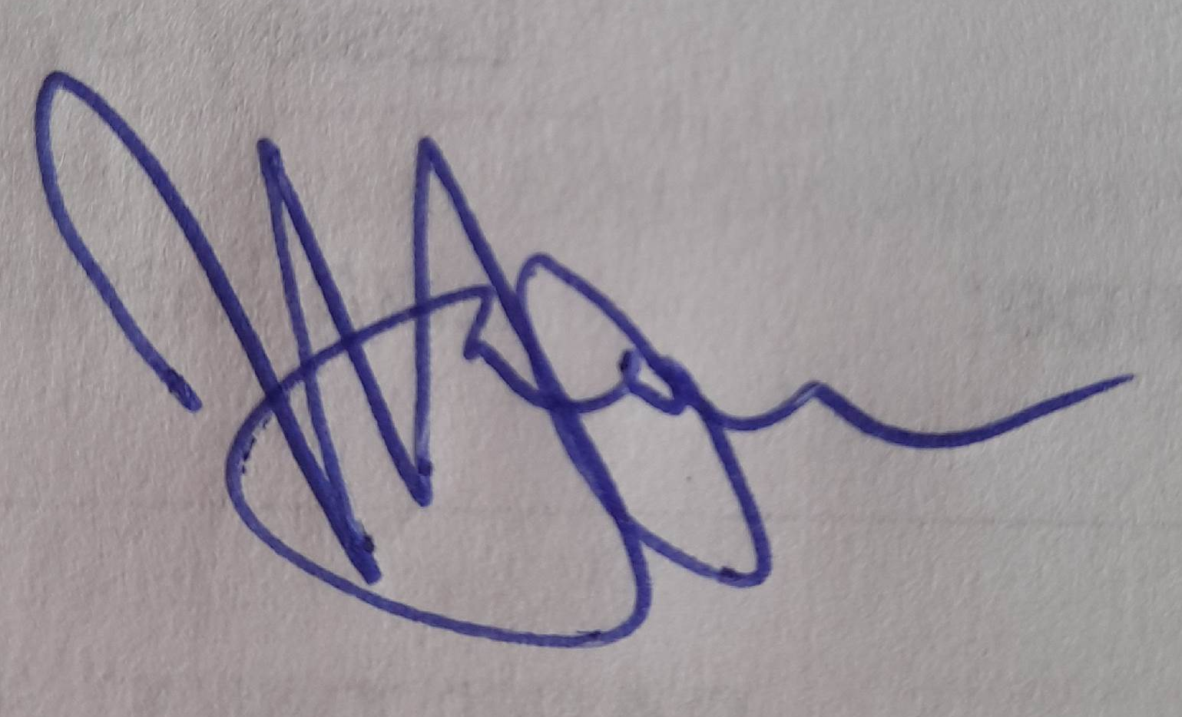
Governors thanked those involved in the completion of the SFVS.

The meeting closed at 4:07pm.

…………………………………………..Chair

…………………04.07.24……………...Date

