MINUTES OF A MEETING OF

THE FULL GOVERNING BOARD OF

ALDERLEY EDGE COMMUNITY PRIMARY SCHOOL
ON THURSDAY 7TH MARCH 2024

GOVERNORS IN ATTENDANCE: Lindsey Walsh (LW) Headteacher
Wendy Davies (WD) Chair (joined the meeting online) Tom Williams (TWi) Acting Chair
Hannah Lomas (HL) Co-opted Governor
Alex Shaw (AS) Co-opted Governor (joined the meeting online)
Katie Bjerkan (KB) Co-opted Governor (joined the meeting online at 5:45pm)
Marc Asquith (MA) Co-opted Governor (left the meeting at 5:16pm)
Mike Lamb (ML) Parent Governor
Mark Ross (MR) Parent Governor
Helen Handley (HH) Co-opted Governor
Sheila Keegan (SK) Local Authority Governor
Lesley Sym (LS) Staff Governor
Martin Smith (MS) Co-opted Governor

OTHERS IN ATTENDANCE: Sarah Lomas Clerk to governors
Lyndsey Platt (LP) Deputy Headteacher

MINUTES – PART ONE: NON-CONFIDENTIAL BUSINESS

5:03pm
ITEM |  | ACTION
APOLOGIES AND ANY OTHER BUSINESS (AOB) ITEMS
Apologies were received and accepted from the following governors:
- NH
- TWe

Governors agreed, that due to online issues for WD, TWi would chair the meeting.

There were no other items of business tabled for discussion at this meeting.
CONFLICT OF INTEREST
- The following declarations were made by governors:
- TWi is a director of Neo Projects Limited.
- ML is an IT director at Quest EPM Limited.
There were no anticipated conflicts of interest with the business of the meeting raised by governors.
MEMBERSHIP
- There were no changes to the membership of the Board of Governors to receive at this meeting.
- Governors noted that the following term of office is due to expire before the next full governing board meeting:
- MA – 24.03.24
MA requested that his term of office be renewed. It was explained that reappointment was not included for consideration as part of this agenda. MA raised an issue with the Board about not considering renewal of his term of office as had been done during previous meetings following the expiry of a term of office. MA claimed that a vote should be taken at this meeting.

WD explained that historically, a number of terms of office were extended for 12 month periods with a view to governors stepping down upon joining TCET. However, given that TCET is no longer a factor, the Strategic Review Committee have reviewed membership and as has been communicated outside the meeting, there are a high number of parents on the Board and balance is sought in this area. MA’s term on the Board is also extensive at 22 years, and the Board have taken advice on best practice to limit the number of terms to two (8 years). WD reiterated her thanks on behalf of the Board for MA’s service as had been previously communicated and explained that MA had been invited to discuss matters with the Chair and Headteacher but had declined to do so.

MA claimed that the communication related to a personal matter that did not concern the Board or the school and that there was no requirement for him to engage in any communication on this matter.

It was clarified that the meeting proposed between MA, WD and LW was requested following concerns raised about MA’s behaviour on school premises and a request was made to discuss these matters but MA declined this invitation.

It was communicated that should MA wish to be considered for the role of co-opted governor he should submit a short biography which will be forwarded to governors and added to the summer term agenda for consideration.

The role of Local Authority (LA) governor was raised and the length of service of SK. MA argued that the previous process has not required submission of a biography. It was confirmed that SK has to reapply for the role with the LA every four years and the decision to reappoint is taken by the LA.

MA claimed there had been no warning or notice of the changes relating to terms of office and that governors should have been consulted. It was confirmed that there was no requirement to consult as the changes reflect best practice and were communicated in writing to MA prior to the meeting.

The Chair requested that this matter be closed as it was not an agenda item for consideration and the meeting needed to progress.

MA left the meeting at 5:16pm.
 | PART ONE MINUTES & MATTERS ARISING  - The Part 1 minutes from the previous meeting were confirmed as a true and accurate record of proceedings. Governors approved the minutes.  ACTION: Upload an electronically signed copy of the minutes to GVO.  - The action log was reviewed and the following item was noted:  - Item 9 – It was agreed that the code of conduct would be issued following the meeting to be signed individually by each governor.  ACTION: Issue the code of conduct to or governors to be individually signed. | Clerk  Clerk
CHAIR’S ACTION
The following action has been taken under the chair’s power to act:
- Further to discussions at the Strategic Review Committee and outside of governor meetings along with advice sought from the Local Authority and the NGA, the decision was taken to follow NGA best practice guidance relating to terms of office.
PART ONE REPORTS FROM COMMITTEES AND REPORTS FROM GOVERNORS WITH SPECIAL RESPONSIBILITIES
To receive:
- Governors confirmed receipt of the minutes from the following committee meetings:
Strategic Review Committee 16.01.24
Teaching and Learning Committee 30.01.24
Assets Committee 13.02.24
An e-mail was issued to all governors following the Strategic Review Committee meeting summarising the main discussion points and setting out the composition of the board.
It was confirmed that financial items discussed at the Assets Committee meeting would be covered under the item 7 of this meeting.
- HH met with the MFL subject lead to undertake a link visit. Governors noted that the subject lead had a very detailed knowledge of MFL and was able to brief HH on all elements of the curriculum.
HH had also undertaken a SEND visit and governors noted that some funding from the PTA had been utilised to provide a relaxation station. There are 10 EHCP's currently in place.
 | FINANCIAL MATTERS  - The draft budget had been circulated to governors prior to the meeting via GVO and the current position shows a deficit for 2024-25 with the school unable to set a balanced budget. Governors were informed that separate meetings have taken place regarding finances and work has been undertaken by the school to reduce the deficit from -£121,000 to -£96,000. Since this time LW and the school bursar have been working to reduce this further to try to provide a balanced budget.  Further discussions regarding the deficit position and the potential savings to be made were discussed under Part 2 of this meeting.  Governors noted that schools are required to set a balanced budget each year but historically, one in 10 schools were unable to set a balanced budget now one in seven schools are unable to set a balanced budget. Governors highlighted the argument that if a school continues to set a balanced budget less money will be received overall in future years.  Governor Comment: As a Board, governors must think strategically going forward and if elements of the curriculum have to be sacrificed in order to set a balanced budget then the school should submit a deficit budget because strategically pupil numbers could be impacted by such changes and it compromises the ethos and vision of the school.  The unique position of the school was highlighted in terms of the statistically competitive neighbours and the fact that the school cannot compete with the independent schools on class size or facilities but the school does offer high quality sports and enrichment and a significant range of free activities for children. School also communicated that they feel that the loss of pupils to independent schools will reduce now that Kings School is full.  Q: In terms of the academisation process, if the school does not have a balanced budget does this mean the school is a less attractive proposition for an existing multi academy trust (MAT)?  A: This is a good point to raise and may be a factor for consideration. Any MAT will undertake due diligence but any actions taken now to balance the budget are simply a temporary measure given the three-year forecasts.  Governors noted that the deficit has increased by over double each year and if savings are made to balance the budget this year, this will not be possible for year two.  Q: If there is a change in government and VAT is applied to private schools, does the school think there may be an influx of students coming from the independent sector?  A: Potentially this could happen. In state schools there is a minimum ratio for staff and the school is not losing significant numbers of pupils so there may not be an overall benefit to this should it happen.  Governors returned to consider the point relating to the attractiveness of the school to a MAT when in a deficit position and highlighted the future financial forecasts and the increasing deficit. Governors were encouraged to put the MAT consideration to one side as there is no definitive answer to this and governors should focus on the immediate issues that are impacting the school today.  Q: Is there an opportunity for the school to submit a -£96,000 deficit rather than the previous -£121,000 deficit?  A: Yes, it has been agreed that the finance papers will be resubmitted to include the additional funds which have reduced the deficit to -£96,000.  Q: Is there a process whereby the school submits the £96,000 deficit but if other opportunities are identified savings could be made?  A: The only savings to be made are those that have been previously identified and discussed under Part 2 of this meeting and these potential savings would only have a small financial impact.  Q: What is the reality of submitting a notice of failure to submit a balanced budget to the Local Authority?  A: In theory the Local Authority could take control of the school finances and the decision-making processes would be taken away from the school. But in reality, the Local Authority is struggling with capacity and there are a significant number of schools in a deficit position so there may not be any direct intervention.  Governors were unable to set a balanced budget and therefore the decision was taken to submit a notice of failure to submit a balanced budget to the Local Authority.  ACTION: Forward the notice for failure to submit a balanced budget form to the school and governors for completion.  - Governors reviewed the budget versus actuals for the current year along with progress against the three-year budget plan. It was noted that the deficit this time last year was £119,000 and the school managed to set a balanced budget in 2023-24 following an increase in income of £80,000.  - Governors noted that the SFVS was underway with a final draft nearing completion. It was agreed that an FGB meeting would be held next week following the document being finalised and circulated to governors.  ACTION: Send a meeting invitation out for an EFGB meeting on 14.03.24 at 4pm.  It was requested that the clerk issue the specific wording around the notice of failure to submit a balanced budget to MR following the meeting for inclusion within the evidence of the SFVS.  ACTION: Forward wording for the SFVS to following the meeting.  ACTION: Upload and circulate the draft SFVS to governors once finalised.  - Governors noted that there were no changes proposed to the staffing structure and the structure of seven classes and seven teachers would remain in place for 2024-25.  - It was confirmed that it would not be necessary for the Assets Committee to approve the final budget due to the submission of the failure to submit a balanced budget notice. This decision would be reconfirmed and minuted at the FGB meeting in the summer term.  ACTION: Add confirmation of the submission of failure to submit a balanced budget notice to the Local Authority to the summer term Assets Committee and FGB agendas.  - Governors noted that the Business Continuity Plan and Cyber Response Plan had been approved at the Assets Committee on 06.02.24. There were no further changes to the Manual of Internal Financial Procedures to be approved at this meeting.  - Governors noted that the impact of the spending of pupil premium funds and the school led tutoring grant have been discussed in detail at the Teaching and Learning Committee. KB has also met with LS in her link role as PP governor and the report from this meeting has been uploaded onto GVO. | Clerk  Clerk  Clerk  LW  Clerk
PART ONE HEADTEACHER’S REPORT AND MATTERS ARISING
The Headteacher’s report had been circulated to governors prior to the meeting via GVO. A summary of the report was provided as follows:
- Pupil and staff wellbeing – A staff survey was issued earlier in the term and the results have been received. Senior leaders are currently compiling an action plan relating to issues raised which centre around teacher workload.
Pupil well-being is positive and there are no issues with parents at present.
- Pupil attendance is currently 95.4% which is above national.
- Health and safety – The issues relating to the fencing around the school site are ongoing and the school are awaiting communication from Cheshire East on these works. The issues with the newly installed boilers are also ongoing the school will need to use an element of DFC funding as Cheshire East claim they are not liable for the repairs. The school confirmed that there were no other immediate health and safety risks.
- Safeguarding – There are no concerns at present. The school continue to work with the Local Authority and other external agencies as required. All staff report incidents and these are logged on the online system. They Headteacher also poses daily challenge questions to staff on safeguarding matters.

An area of focus for safeguarding was the impact of the curriculum on well-being and the school uses the My Happy Mind scheme to support this area of focus. The school has received positive feedback from parents from one particular child who has been supported with interventions in this area.
Q: What would the school identify as successes for this term?
A: There have been successes relating to behaviour and curriculum however the oracy target still requires work. Other areas have not been able to be implemented due to the lack of funding within the budget.

Governors thanked the Headteacher for their comprehensive report.

Pupil voice obtained during the safeguarding link visit raised that pupils felt there were not enough staff on the playground during break time. The school confirmed that the staff ratios on the playground were sufficient but that staff visibility was not perhaps as obvious to pupils and therefore staff are now wearing high visibility jackets on the playground to increase the visibility of staff.

It was also noted that governors continue to review the SDP during visits to school.
SCHOOL DEVELOPMENT PLAN
The school development plan had been circulated to governors prior to the meeting and was also discussed in part under Item 8. The school commented that significant progress has been made with behaviour and the school curriculum.
Q: What is the timeline for the Ofsted inspection?
A: The school are still in the window for inspection prior to the end of the calendar year.
SCHOOL IMPROVEMENT PARTNER (SIP)
- Governors noted that the latest report from the SIP has been uploaded to GVO. This report was based on a deep dive into history and the SIP confirmed that the school have progressed significantly with the history curriculum and the SIP was pleased with the impact and progress.
 | ACCESSIBILITY PLAN  The school confirmed that the Accessibility Plan did not require approval as it was approved in spring 2023 and is on a two year cycle of review.  ACTION: Add approval of the accessibility plan to the spring 2025 FGB agenda. | Clerk
STRATEGIC GOVERNANCE – ORGANISATIONAL ARRANGEMENTS AND CLERKING ARRANGEMENTS FOR 2024/25
Governors confirmed the approval of the buy back of the Cheshire East clerking service for 2024-25 at the same level as 2023-24 to cover all committees and FGB meetings including Pay Committee.
 | GOVERNOR TRAINING & DEVELOPMENT  - WD provided a summary of training over the course of the spring term. Governors continue to be active in their development which is very positive. Emails are circulated regularly regarding available training courses.  All link roles have now been assigned and thanks were issued to ML for taking on the computing link role. Thanks was also given to ML and MR for undertaking the SFVS training.  The website compliance review was discussed and KB agreed to undertake the annual review of the website in the summer term.  ACTION: KB to undertake a website compliance review in the summer term.  Review of the delegation planner was required in the spring term and it was suggested that MS undertake this review supported by AS.  ACTION: MS and AS to undertake a review of the delegation planner in the summer term.  - Governors communicated that the SFVS training was poor and not engaging for participants.  - It was agreed that alternative templates would be sourced for the summer term.  ACTION: Source alternative board review templates and issue to the Chair for review.  - It was agreed that say skills audit would be undertaken in the summer term.  ACTION: Forward details of the GVO skills audit 2 governors at the end of the spring term.  ACTION: Forward the financial skills matrix to finance governors for completion.  Governors were informed that the school science week takes place next week and WD is unable to attend in her capacity as link governor. Governor representation is welcomed and the invitation was extended to all governors. | KB  MS/AS  Clerk  Clerk  LW
SCHOOL POLICIES
The following policies had been circulated to governors prior to the meeting for review:
- 5 – Admissions
- 36 – Child Protection and Safeguarding – some updates from guidance
Governors approved the above listed policies.
PLANNED RESIDENTIAL VISITS
The following planned visits had been previously approved and an update was provided as follows:

The trip to Whitehall on 22-24th April has been confirmed.

Q: Have the risk assessments for the trip been completed?
A: These are underway and will be sent to the LA at least 20 days prior to the visit in line with requirements.
 | TO NOTE ARRANGEMENTS FOR PRODUCTION OF MEETING PRECIS  ACTION: WD to complete meeting precis. | WD
MEETINGS
The next full governing board meeting date was confirmed as Thursday 4th of July at 5:00pm in school.
ANY OTHER BUSINESS
There were no other items of business tabled for discussion at this meeting.
IMPACT STATEMENT
Governors helped to move the school forward in the following ways during this meeting:
- Governors considered the financial position of the school and the requirement to strategically plan for the future of the school with an action taken to submit a failure to submit a balanced budget notice to the Local Authority.
- Governors challenged the progress against the targets set out within the school development plan with an update received on successes and areas for improvement.
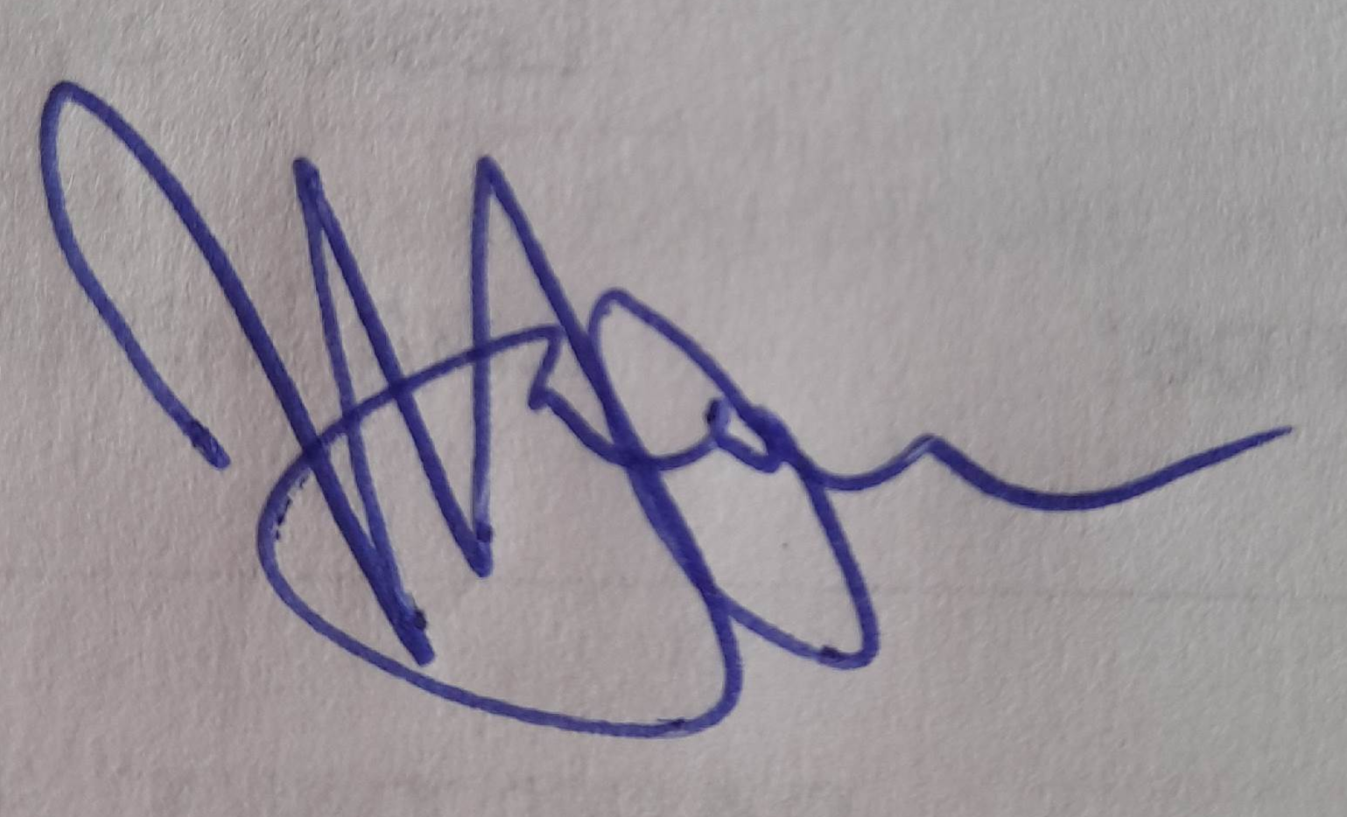
- Safeguarding was discussed and evidence of compliance following link visits was highlighted along with updates on internal monitoring of incidents.

The meeting moved to Part Two.

…………………………………………..Chair

………………04.07.24…………………Date

