MINUTES OF AN EXTRAORDINARY MEETING OF

THE FULL GOVERNING BOARD OF

ALDERLEY EDGE COMMUNITY PRIMARY SCHOOL
ON TUESDAY 11TH JUNE 2024

GOVERNORS IN ATTENDANCE: Lindsey Walsh (LW) Headteacher
Wendy Davies (WD) Chair (joined the meeting online) Tom Williams (TWi) Co-opted Governor
Hannah Lomas (HL) Co-opted Governor
Alex Shaw (AS) Co-opted Governor (joined the meeting online)
Mike Lamb (ML) Parent Governor
Mark Ross (MR) Parent Governor
Helen Handley (HH) Co-opted Governor
Sheila Keegan (SK) Local Authority Governor
Lesley Sym (LS) Staff Governor
Martin Smith (MS) Co-opted Governor
Nick Hughes (NH) Acting Chair

OTHERS IN ATTENDANCE: Laura Furness Clerk to governors
Lyndsey Platt (LP) Deputy Headteacher

MINUTES – PART ONE: NON-CONFIDENTIAL BUSINESS

5:03pm
ITEM |  | ACTION
 | APOLOGIES AND ANY OTHER BUSINESS (AOB) ITEMS  There were no apologies to receive.  AOB  - Coordination of a collection for MA/KB  MA has stepped down from the AECPS governing board. KB has resigned following a new role at Astra Zeneca. KB has confirmed that she is committed to completing all outstanding governor responsibilities. NH has organised two bank accounts for governor donation and cards will be available to sign at school.  ACTION: Coordination of outgoing governor collections  - Prevent refresher training-reminder  The clerk sent a training email to governors week commencing 03.06.24. The refresher course takes approximately 20 minutes to complete. The skills audit was sent out and governors were reminded to complete and return this document by 21.06.24.  ACTION: To complete and return governor skills audit  There have been five responses on the Governor 360 board review. Governors are asked to complete the paper document on Google forms by 21.06.24  ACTION: To complete the Governor 360 board review. | NH  ALL  ALL
CONFLICT OF INTEREST
- The following declarations were made by governors:
- TWi is a director of Neo Projects Limited.
- ML is an IT director at Quest EPM Limited.
- NH is a governor at Rushton First School.
There were no anticipated conflicts of interest with the business of the meeting raised by governors.
MEMBERSHIP
- The board approved the reappointment of NH as a co-opted governor. The HT noted that governance guidance recommends two terms of office, but in exceptional circumstances, this can be extended. The current CoG is currently sick but is to return in the near future and during this time governors approved NH as Acting Chair.

Q: How long is a term of office?
A: Four years. A governor can however decide to resign at any point.

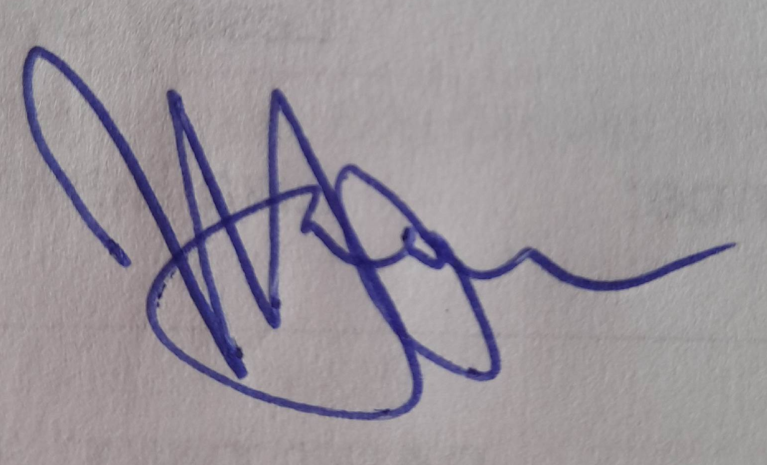
The meeting moved to Part Two.

…………………………………………..Chair

…………………04.07.24……….…..…Date

