9th February 2023

Dear Parents,

**World Book Day Plans**

This year we will be celebrating World Book Day on **Friday 8th March.** The theme this year for our school World Book Day is linked with **SCIENCE** as science week runs this week too. Come as your favourite scientist, a character from a science-fiction book, your favourite animal, or perhaps you’ve read a fantastic novel about aliens or robots from the world of science-fiction! Anything, as long as your outfit is linked with science!



Children will need to bring in a book their chosen character is from (non-fiction books are welcome too!) as we will be conducting reading buddy sessions where different year groups will read their book to one another.

We also have a book fair running in school on Thursday 14th March. You can pay by cash or card, as we have a card machine available this year.



We look forward to another fun filled day this year and hope you will encourage your child to join in these celebrations.

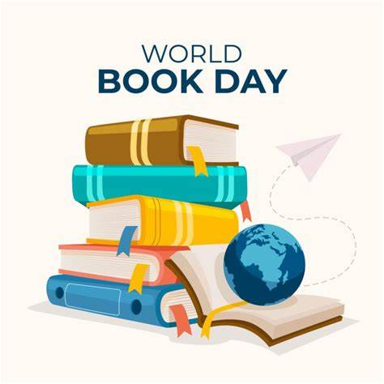

Yours Sincerely,

Miss Hibbert

Year 5 Teacher