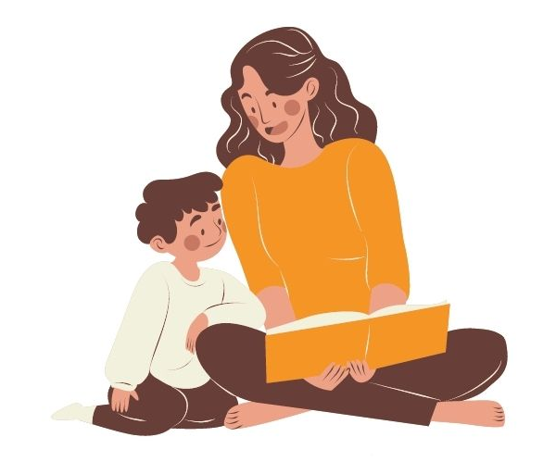
Alderley Edge Library Visit
Alderley Edge Community
Primary School
Dear Parent,

Your child is due to visit the library
with their school. During the visit there will be an opportunity to select one book to take home.

If you would like your child to have this opportunity and they are a member of the library please allow them to bring their library card into school on that day.

If your child has not previously joined the library and you would like them to do so, please could you complete the enclosed membership card and sign the parental declaration, returning it to the school as soon as possible. Your child will then be able to select one book to take home on the day of our visit.

Don’t forget the library has lots of things to do for all the family, all your favourite books to borrow for FREE, browse the internet for FREE, online magazines, e-books and e-audio all accessible for FREE, as well as lots of events throughout the year.

Come along with your family to discover and enjoy your library.
We look forward to meeting you,

Alderley Edge Library
44 London Road
Alderley Edge
Cheshire
SK9 7GP

