

Information from the 0-19+ School Nursing Team about school age vaccinations

- Transitioning from Early Years to Primary School
Starting school can be both an exciting and nerve-wracking time for you and your child. Your little one is about to take a big step and start a new chapter of their life.
There are lots of tips on 0-19+ Service website to help make this transition go as smoothly as possible.
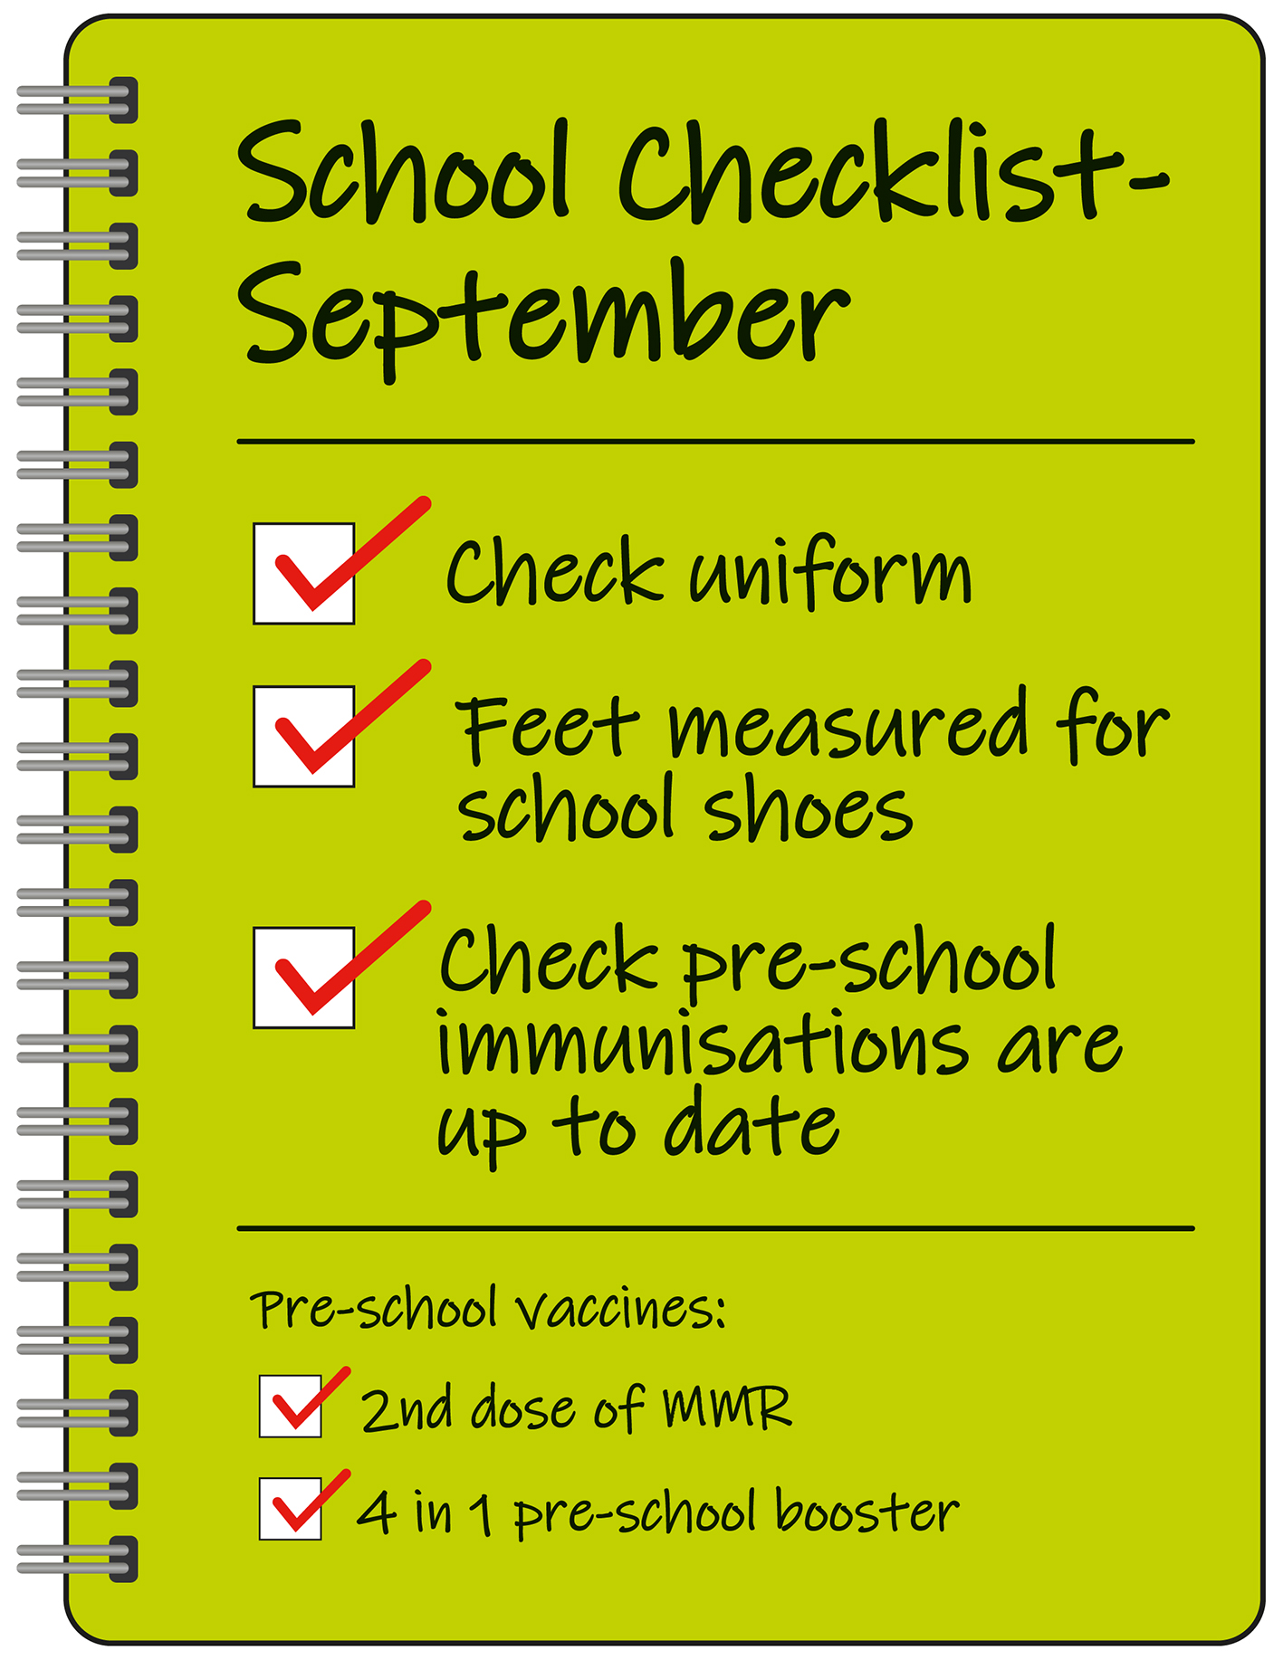
Before your child starts school in September they should have been immunised against the following:
2nd dose of MMR (measles, mumps and rubella) vaccine. This vaccine portects against 3 serious illnesses: measles, mumps and rubella (german measles)
4-in-1 pre-school booster. This vaccine protects against 4 different serious conditions: diphtheria, tetanus, whooping cough and polio

Speak to your GP surgery if:
- you think your child has missed any vaccinations
- your child has a vaccination appointment - but you have missed it or cannot attend

They can book or rearrange the next available appointment.
It’s best to have vaccines on time, but you can still catch up on most vaccines if you miss them.
For more information about school age vaccinations please visit the government website.

- Primary School
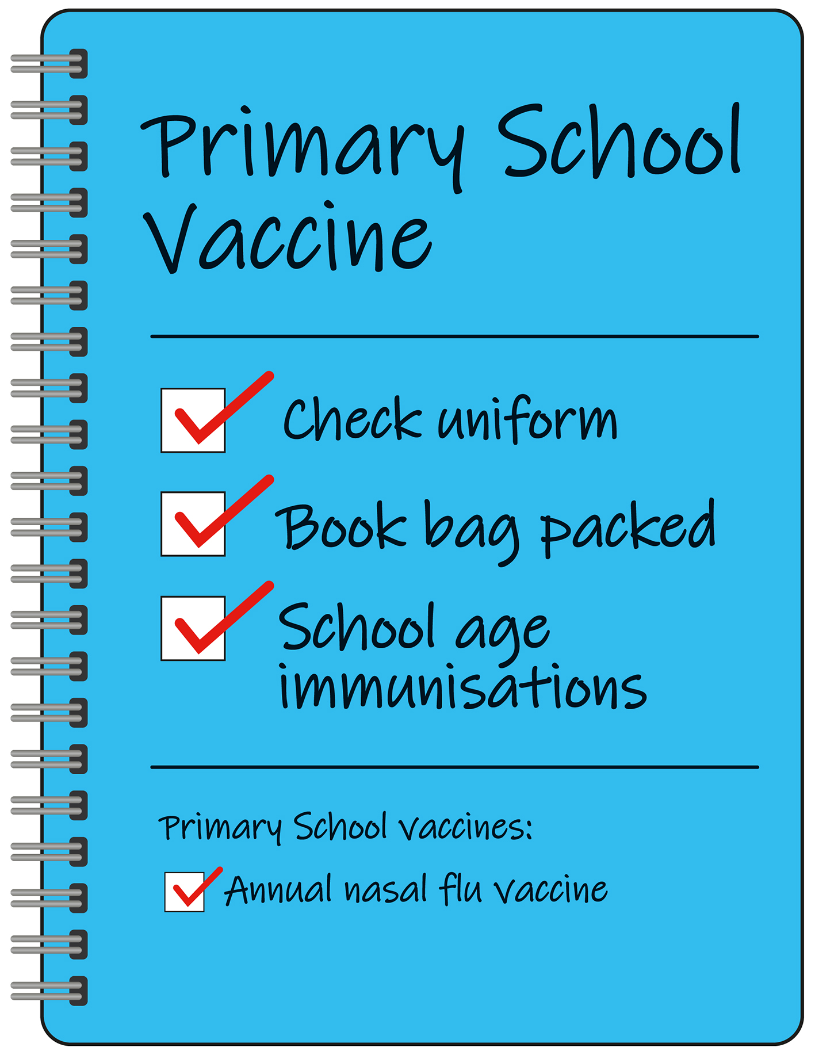
Your child will be offered their nasal flu spray between September to December throughout their time in Primary School (reception to year 6).
The children's nasal spray flu vaccine is safe and effective. It's offered every year to children to help protect them against flu.
Flu is caused by the influenza virus. It can be a very unpleasant illness for children. It can also lead to serious problems, such as bronchitis and pneumonia
Children can catch and spread flu easily. Vaccinating them also protects others who are vulnerable to flu, such as babies and older people.

Speak to the 0-19+ Immunsiations Team if:
- you think your child has missed their annual flu vaccine
The team can book or rearrange an appointment. Contact the team via email - wcnt.immunisation@nhs.net
You can find out more information about the nasal flu flu vaccine on the NHS website.

- Secondary School
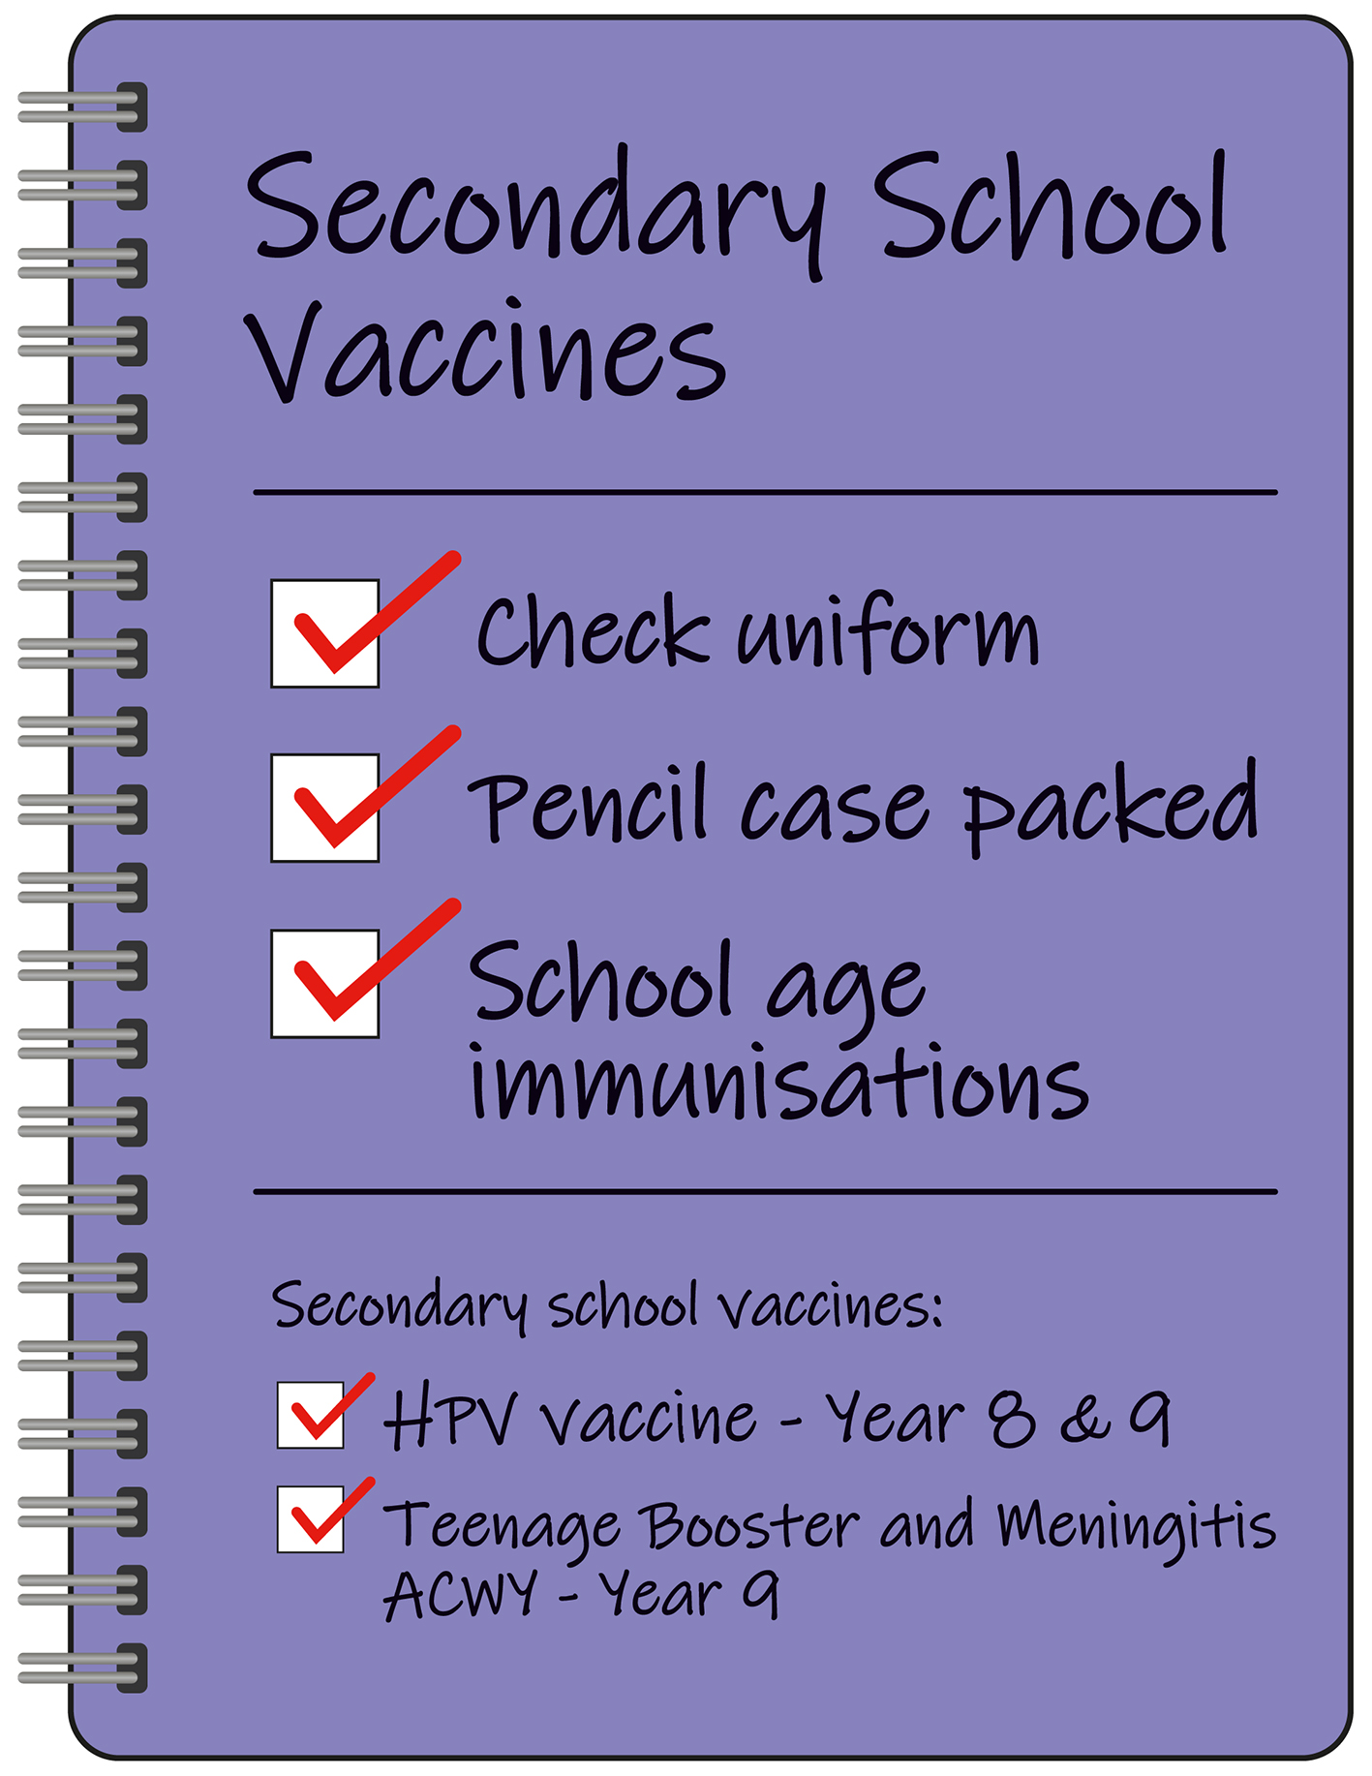
Your child will be offered the following vaccines:
Year 8 - HPV vaccine. The HPV vaccine helps protect against cancers caused by HPV, including: cervical cancer, some mouth and throat (head and neck) cancers and some cancers of the anal and genital areas.
From 1st September 2023 the HPV vaccine programme will change from a two dose to a one dose vaccine schedule for eligible adolescents
Those in school year 9 and above who have already received one HPV vaccination will be considered fully vaccinated. They will not require a second dose. Those in school year 9 and above who have not yet received any HPV vaccinations will be eligible to receive one dose of the HPV vaccine.

Year 9 - Teenage Booster. The teenage booster, also known as the 3-in-1 or the Td/IPV vaccine, is given to boost protection against 3 separate diseases: tetanus, diphtheria and polio.
Year 9 - Meningitis ACWY. The MenACWY vaccine protects against 4 strains of the meningococcal bacteria - A, C, W and Y - which cause meningitis and blood poisoning (septicaemia).
Your child may be offered their nasal flu spray between September to December, dependant on the request from NHS England.
The children's nasal spray flu vaccine is safe and effective. It's offered every year to children to help protect them against flu.
Flu is caused by the influenza virus. It can be a very unpleasant illness for children. It can also lead to serious problems, such as bronchitis and pneumonia
Children can catch and spread flu easily. Vaccinating them also protects others who are vulnerable to flu, such as babies and older people.

Please contact the 0-19+ Immunsiations Team if:
- you think your child has missed a vaccination appointment. The team can book or rearrange an appointment.
- Contact the team via email - wcnt.immunisation@nhs.net
For more information about school age vaccinations please visit the government website.

