Alderley Edge Community Primary School
TOPIC: Should The Punishment Fit The Crime? | Strand: Changes over time | Year 6
Vocabulary
accused | The person blamed or charged with a crime
arrest | to seize and hold or imprison for breaking the law
arson | the crime of burning buildings on purpose
brank | A head cage worn by women accused of gossiping
capital punishment | punishment, of a crime such as murder, by death
defendant | one who is accused or sued in a court of law
felon | a person who has committed a serious crime
Heresy | The crime or act of speaking out against religious teachings
Judge | a person trained to hear and decide cases brought before a court of law
Jury | a group of people called to a court of law who listen to the facts of a case and decide its outcome
justice | the upholding of what is fair, just, and right
lawyer | one whose job is to help people with legal matters and represent them in court
perpetrator | The person who carries out a crime
pickpocket | a person who steals from pockets or purses in crowded or public places
pillory | a wooden structure that had holes for holding a person's head and hands
prosecute | to begin or carry on a court action against in order to enforce the law
prison | a building for holding and punishing people who have broken the law
rehabilitate | To support the criminate so they do not commit the offence again
retribution | Repayment for one's actions, esp. punishment for evil.
tithing | Anglo-Saxon system - a group 10 men responsible for each other’s behaviour. If one broke the law the others had to report him or pay a fine
theft | To take something that does not belong to you
treason | the betrayal of one's country or to go against the monarch
Trial | the act of hearing a case in court to decide whether or not a person has broken a particular law
vandalism | destruction or damage of property that is done on purpose
Victim | To person or people who suffer as a result of the crime
What will I know by the end of the topic?

- Different types of crimes and how they were punished in different periods of history including
  - Romans
  - Vikings and Anglo-Saxon
  - Tudors
  - Victorians
  - 21st century
- Know how crimes were detected and criminals were tried in different periods in history
- Know the most common types of crimes and identify commonalities and differences and reasons for this
- Define terms such as judge, jury, pillory, lawyer, heresy, treason, justice, brank, stake, pyre, tithing
What I already know
What should I already know?
- The chronology of British history.
- That changes happen over time as a result of different beliefs, systems and social changes from the different invaders and settlers in British history
- Aspects of life in Roman, Viking, Anglo-Saxon and Victorian time periods including daily life, democracy, communication
- Know how technology has changed over time.

Historical enquiry skills I will develop
- To describe the broad trends in crime and punishment from roman times to the 21st century
- Suggest ways that crimes and punishments have change over tine
- To find similarities and differences in the types of crimes committed and how they were punished in the different periods of history
- To debate the notion of justice and if the punishment should fit the crime.
- To explain their beliefs and justify onion with evidence.

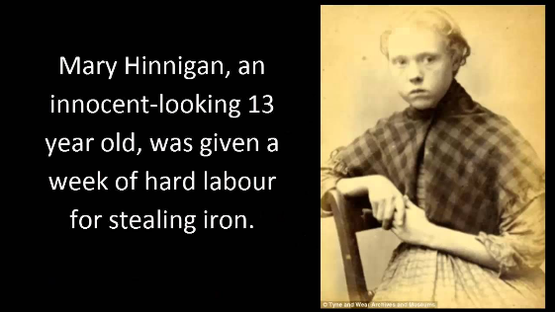

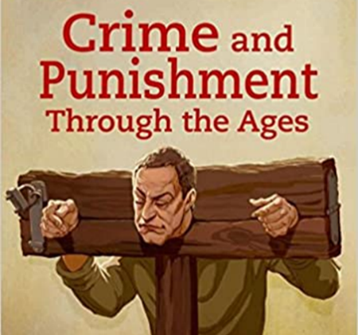

People
King Henry ll | The seeds of the modern justice system were sown by Henry II (1154-1189), who established a jury of 12 local knights to settle disputes over the ownership of land
Sir Robert Peel | Robert Peel was twice British Prime Minister and responsible for setting up the first police force in London in the 1800s

